**Bachelor of Engineering (Honours) in Software and Electronic Engineering**

**GMIT Department of Electrical and Electronic Engineering**

**Year 1**

**Industrial Automation**

**Gabriel Farragher 2022**

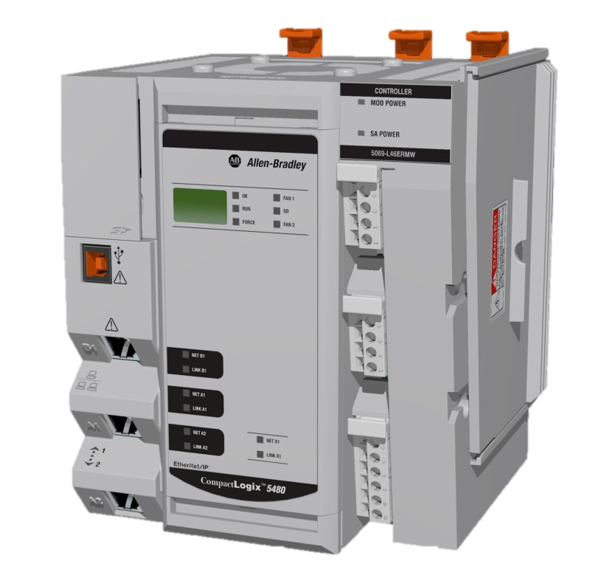

# Student Details:

* Date: January – April 2022
* Module: Industrial Automation
* Student Name:
* Student Number:
* Lecturer: Gabriel Farragher
* Document: Lab Reports

# Table of Contents:

1 Student Details: 2

2 Table of Contents: 3

3 Table of Figures: 3

4 Lab 7 Ex 1 Sequence Programming Continued: 5

# Table of Figures:

No table of figures entries found.

**Notes:**

|  |
| --- |
|  |
|  |
|  |
|  |
|  |
|  |
|  |
|  |
|  |
|  |
|  |
|  |
|  |
|  |
|  |
|  |
|  |
|  |
|  |
|  |

# Lab 7 Ex 1 Sequence Programming Continued:

Specification: The Mitsubishi PLC controls an 8-segment sign with the following sequence:

WELCOMEE

**PLC I/O Addresses:**

**Input Schedule:**

* **X1 DI01 iStart_PB**

**Output Schedule:**

* **Y0 DO00 oBorder**
* **Y1 DO01 oW_Letter**
* **Y2 DO02 oE1_Letter**
* **Y3 DO03 oL_Letter**
* **Y4 DO04 oC_Letter**
* **Y5 DO05 oO_Letter**
* **Y6 DO06 oM_Letter**
* **Y7 DO07 oE2_Letter**

**[Note: Save PLC software file as: GX W2 L7 Ex 1 GF]**

**Using LL/FBD write the sequence for the following:**

1. Sequence begins when Switch DI01 [X1] is turned On.
2. The Border and the letter W immediately on.
3. E1 on for the next 5 seconds then Off,
4. L on for the next 5 seconds then Off,
5. C on for the next 5 seconds then Off,
6. O on for the next 5 seconds then Off,
7. M on for the next 5 seconds then Off,
8. E2 on for the next 5 seconds then Off,
9. Then all letters including border flash for 10 seconds.
10. Then the sequence repeats. The sequence will continue until the Sequence Switch DI01 switch is turned Off.

Develop a commented Sequence program for the above.

**Save PLC file as:** **GX W2 L7 Ex 1 GF A**

**Here is some help on where to begin:**

**Note:** M8002 is a special memory bit Mitsubishi PLCs use, and **pulses once** at **power up** or when **you turn simulation on**. It is used to reset or bring any **sequence back to the start.**

